Chmielek Sklep

Project Number | 0.1
Project Name | Chmielek Sklep
Author | Krzysztof Bulik, Grażyna Zawora, Artur Polański, Mateusz Utkała
Last Updated | 8/11/26 13:37 [auto-date]
Version Number | 0.6
Status | Draft
Solution Owner | Grażyna Zawora

Changes and Reviews

Time  Stamp | Editor or  Reviewer | Organization Unit | Change  Scope
17.05.2014 | Artur, Krzysiek |  | Beta version
19.05.2014 | Grażyna |  | Beta version
20.05.2014 | Krzysiek |  | UML Diagrams
14.06.2014 | Krysiek |  | UML Diagrams
16.06.2014 | Mateusz |  | UML Class Diagram
16.06.2014 | Krzysiek |  | Corrects

Introduction

Purpose

This document will provide a solution to business requirements for a shop with an option to sell products online. The aim of the project is to create a sales/deliveries management system. The project will consist of three parts. First, content management, transactions management and deliveries management. Second, the website for the shop. Third, an android app for the shop.

Terminology

Term | Definition
App | Application
Username | Name someone uses for logging
DB | Database

Related Documents

Document Name | Date | Author | Version
Fds – projekt.doc | 3.04.2014 | Krzysztof Bulik, Grażyna Zawora, Artur Polański, Mateusz Utkała | alpha
Folder spotkania | 17.06.2014 | All programmers and client | beta

Required Skills

The following skill sets are required to complete this development:
Skill | Level Required | Comments
C# / .NET | Intermediate-level | Krzysztof Bulik, Artur Polański
Data Bases | Intermediate-level | Krzysztof Bulik, Artur Polański
Network | Intermediate-level | Grażyna Zawora
Android | Intermediate-level | Mateusz Utkała
Java | Intermediate-level | Mateusz Utkała
Spring | Intermediate-level | Grażyna Zawora
Angular JS | Intermediate-level | Grażyna Zawora

Client Summary

Executive Summary of Solution

Introduction

C# will be the main programming language. The project will use an online MySQL database, with Entity Framework used as an ORM. Store website will be done in Spring MVC, Spring JPA, Bootstrap. Android app will be executed in JDBC.

Business Requirements Summary

 | Area | Requirement
 | Client application | Accounts, products management
 | Website | Viewing and ordering products
 | Android application | Viewing products

Client application should be able to manage products which consists of adding new product, deleting product from DB and changing its properties. This type of control should also refer to accounts and deliveries.

Android application should server customers mostly for viewing and searching products, but there is a possibility to order product and managing a shop cart. GUI is very strict and esthetic without any non-necessary additions.

Website serves this system for clients who do not have Android system or prefer to use browsers. The functionality of the website is the same of the android application.

Proposed GUI of client application:

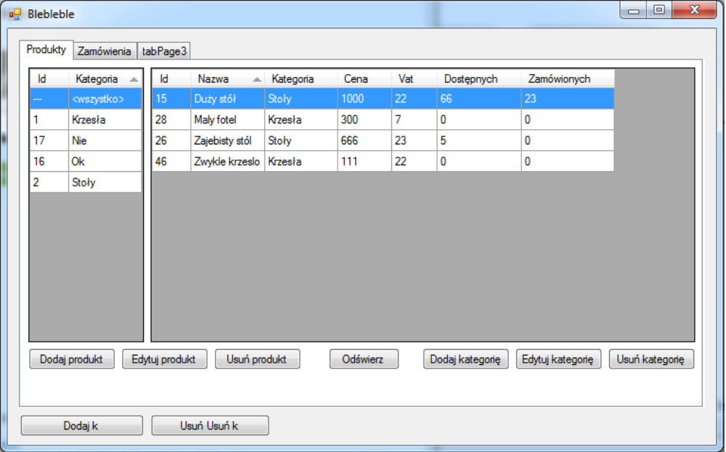

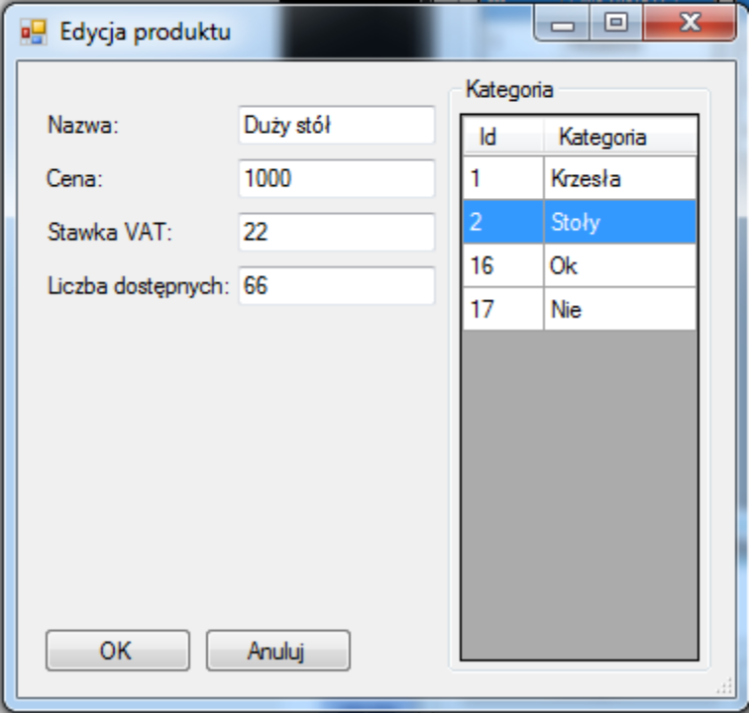
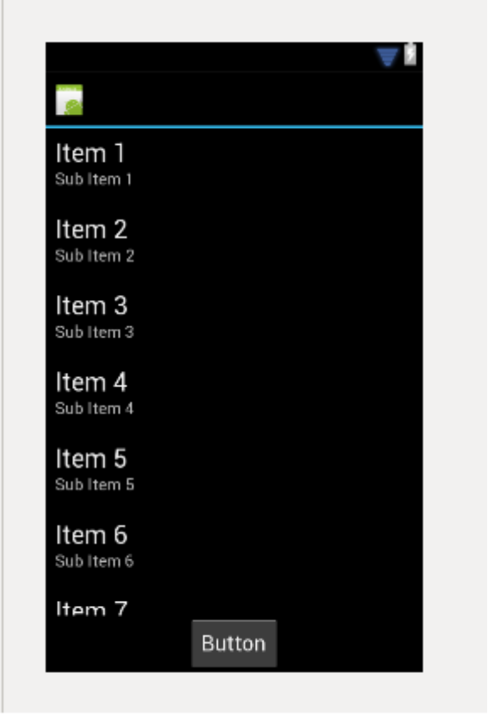
Proposed GUI of Android Application

System Functionality Summary

The system will comprehensively support managing various components of the store (adding, modifying, deleting etc.). The website/android app will provide a way to browse available products, add them to cart etc.

 | Function | Description
 | Managing users | Adding, deleting, modifying, searching, viewing details (like ordered products) (Client application)
 | Managing products | Adding, deleting, modifying, searching, viewing details (like prices, VAT, providers) (Client application)
 | Managing categories | Adding, deleting, modifying, searching, viewing products that fall under a specific category (Client application)
 | Managing deliveries | Adding, deleting, modifying, searching, viewing details (like products delivered, provider that delivered) (Client application)
 | Managing providers | Adding, deleting, modifying, searching, viewing details (like deliveries from that provider) (Client application)
 | Managing orders | Adding, deleting, modifying, searching, viewing details (like products ordered, user who ordered) (Client application)
 | Listing products | Viewing list of products (Client and Android application, Website)
 | Listing orders | Viewing list of products (Client, Android application, Website)
 | Searching products | Being able to search for a specific product using search input (Android, Client application, Website)
 | Shopping cart | Adding to cart, browsing products in cart and finalization order (Website and Android)

Assumptions
Assumption
The system will only provide means to order products (website/android app) and manually changing the status of the order after it has been realized
Website as well as clients applications
Sales items will have Polish names
Payments in store will operate only in Polish currency

Constraints

Constraint
Database accessible online
Tomcat server must be accessible online
Safe connection with database

Implementation Implications

Pre-Requisites

Pre-requisite
.NET Framework for client application (Client Application)
Android v2.3.6 or newer (Android Application)
5 MB free space for cache data (Android Application)

Data Conversion & Cleansing

There is conversion between string by using encoding to MD5. This is used in all three components of the system (website, client app, android app).

Conversion Method

// Dla C#

public string CalculateMD5Hash(string input)
{
MD5 md5 = System.Security.Cryptography.MD5.Create();
byte[] inputBytes = System.Text.Encoding.ASCII.GetBytes(input);
byte[] hash = md5.ComputeHash(inputBytes);

StringBuilder sb = new StringBuilder();
for (int i = 0; i < hash.Length; i++)
{
sb.Append(hash[i].ToString("X2"));
}
return sb.ToString();
}

// Dla Java & Android

public static String md5(String s)
{
MessageDigest digest;
try
{
digest = MessageDigest.getInstance("MD5");
digest.update(s.getBytes(),0,s.length());
String hash = new BigInteger(1, digest.digest()).toString(16);
return hash;
}
catch (NoSuchAlgorithmException e)
{
e.printStackTrace();
}
return "";
}

Test Impacts
Client application tests:
-loggin using either wrong password or username
-setting price below 0 in client application
-registration using existing username
-partial registration ( not giving all required information)
-accessing database offline

Android application tests:
-logging using either wrond password or username
-ordering product which is selled out
-registration using existing username
-access offline

Training Impacts

System is very intuitive thus it does not require much skill to handle. This system is designed for a small group of people preferable one who is the owner of small company. Following both installation guide as well as user instruction are enough to perfect Klient. In case of any trouble please contact using mail – chmielek@gmail.com

Functional Overview

Hardware requirement

With over 1000 user and about 1000 products in database system will require server configuration:

E3 Ivy Bridge
3.3GHz e3-1230-V2
4 GB DDR3 RAM
500 GB SATA III HDD
5 TB Transfer

Or better to response user request in less then 0.5 sec.

Software requirements

This system consists of many elements. To run website it is required from user to just use internet browser. Database for proper operating requires 50MB of server space. For client application .Net Framework 4.0 or higher is required.

Regular expressions

We use regular expressions in login section in Android application. Where user can make a mistake like inserting space or use forbidden chars.
Our regular expression is: "[A-Za-z\\d]+"

UML Diagrams

Activity Diagram
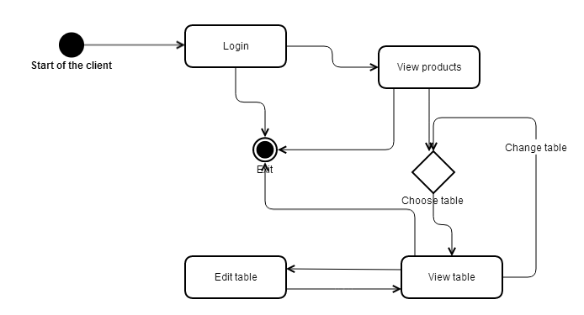

Use Case Diagram (Client application)
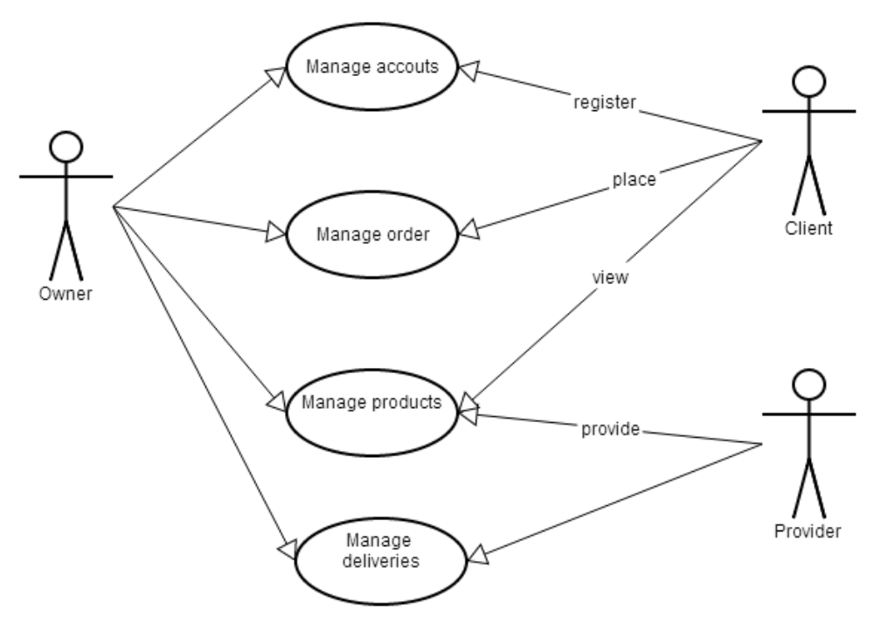

Use case Diagram (Android application)

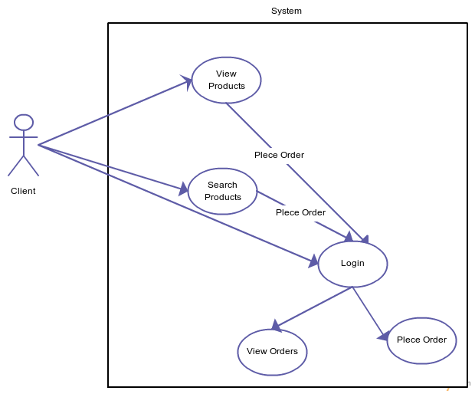

Sequence Diagram (ordering product)

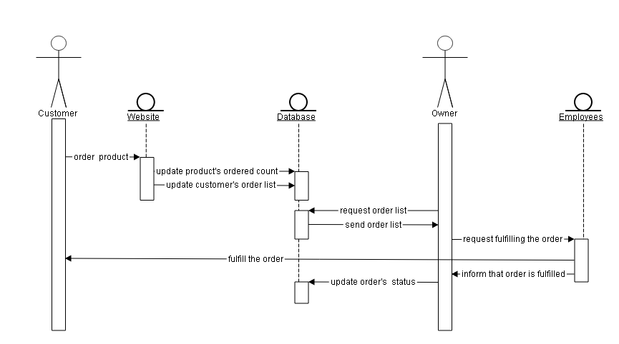

Sequence Diagram( Android application)
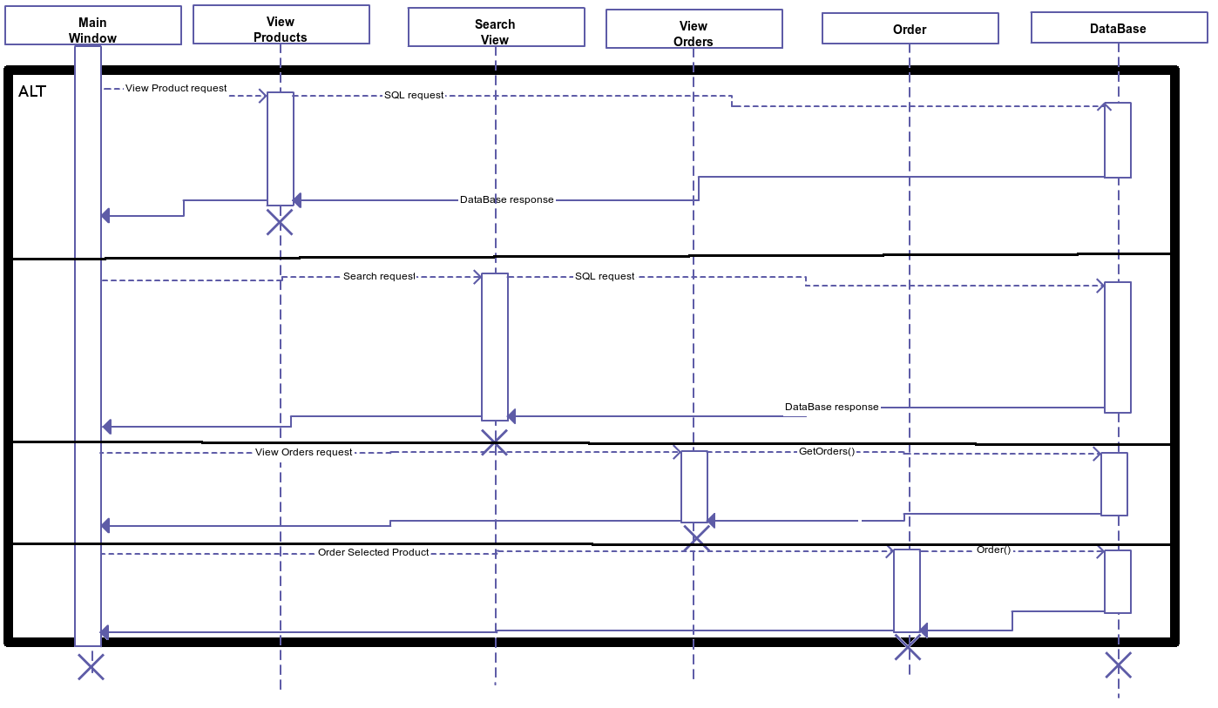

Connection Diagram( Android application)

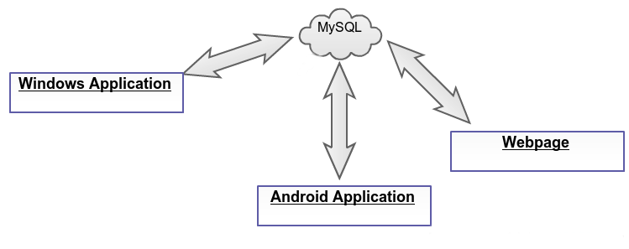

Components Diagram

Class Diagram(Android)
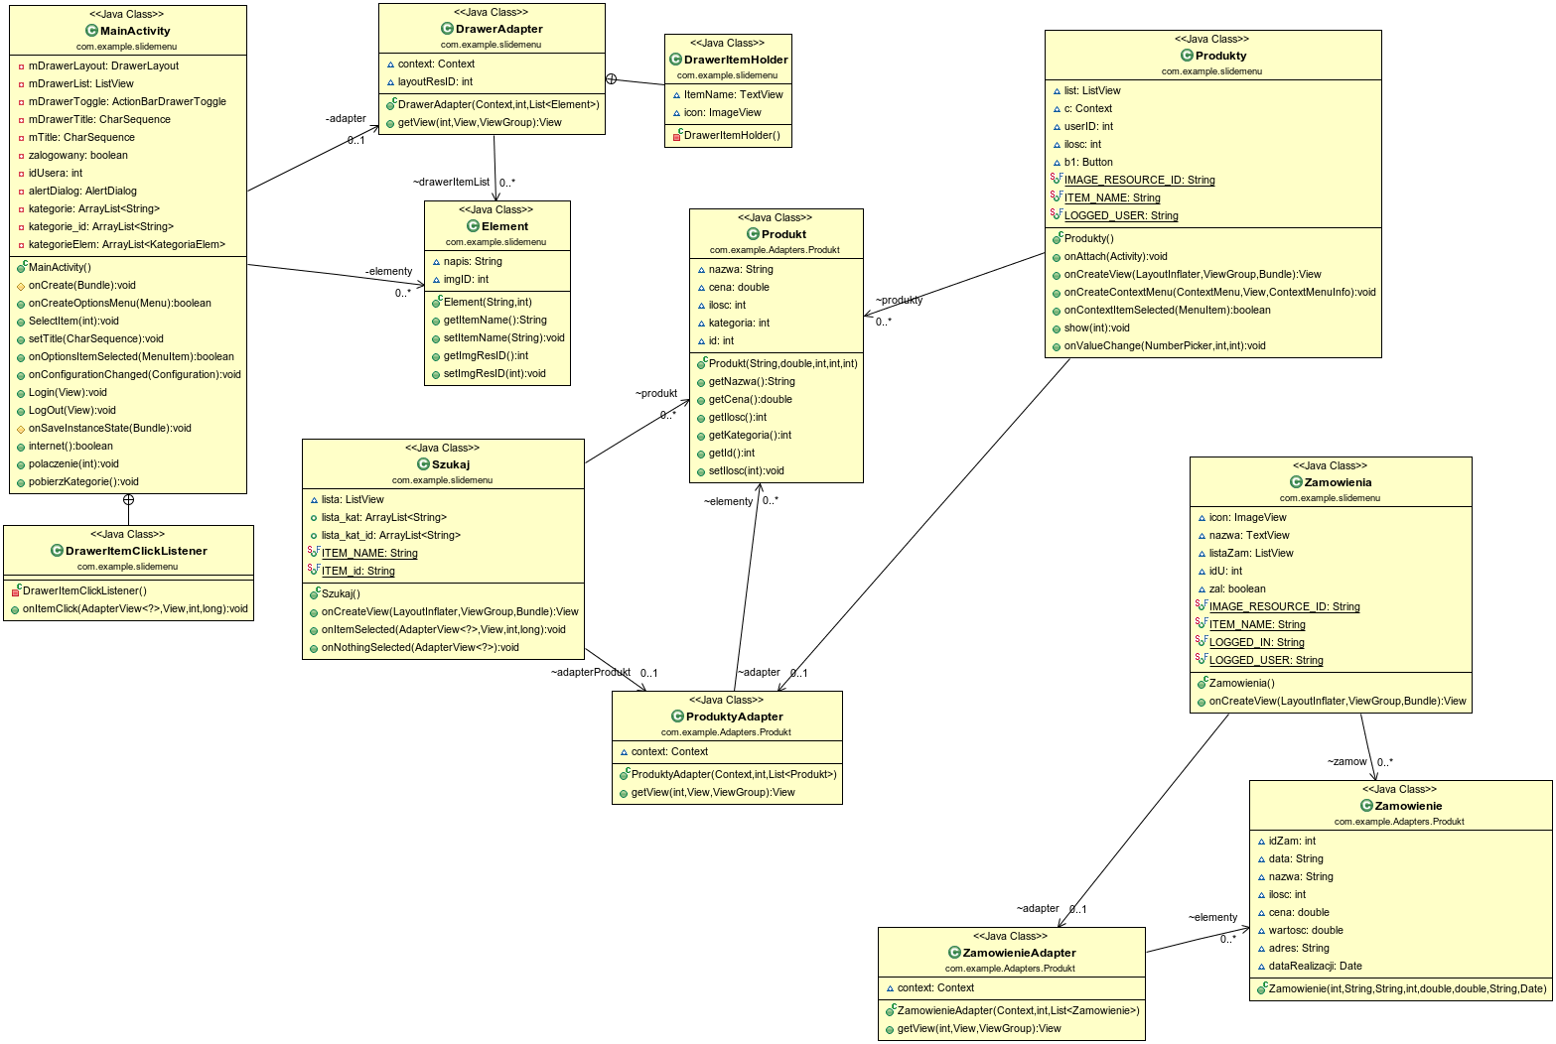

Class Diagram(Client application)
Due to complexity of the diagram it is included with other additional documents as ClassDiagram1.png. file.

Design Summary
[Summarize the design, identifying all the new components required for the solution. For a small solution such as a change request, this table may be very detailed. For a large solution the table can remain high-level.]

Requirement | Component | Type | Sizing
[References section 2.1.2] | [Name of component] | [Program/  Schema Change/  Screen] | [Small Medium Large ]

Database Design

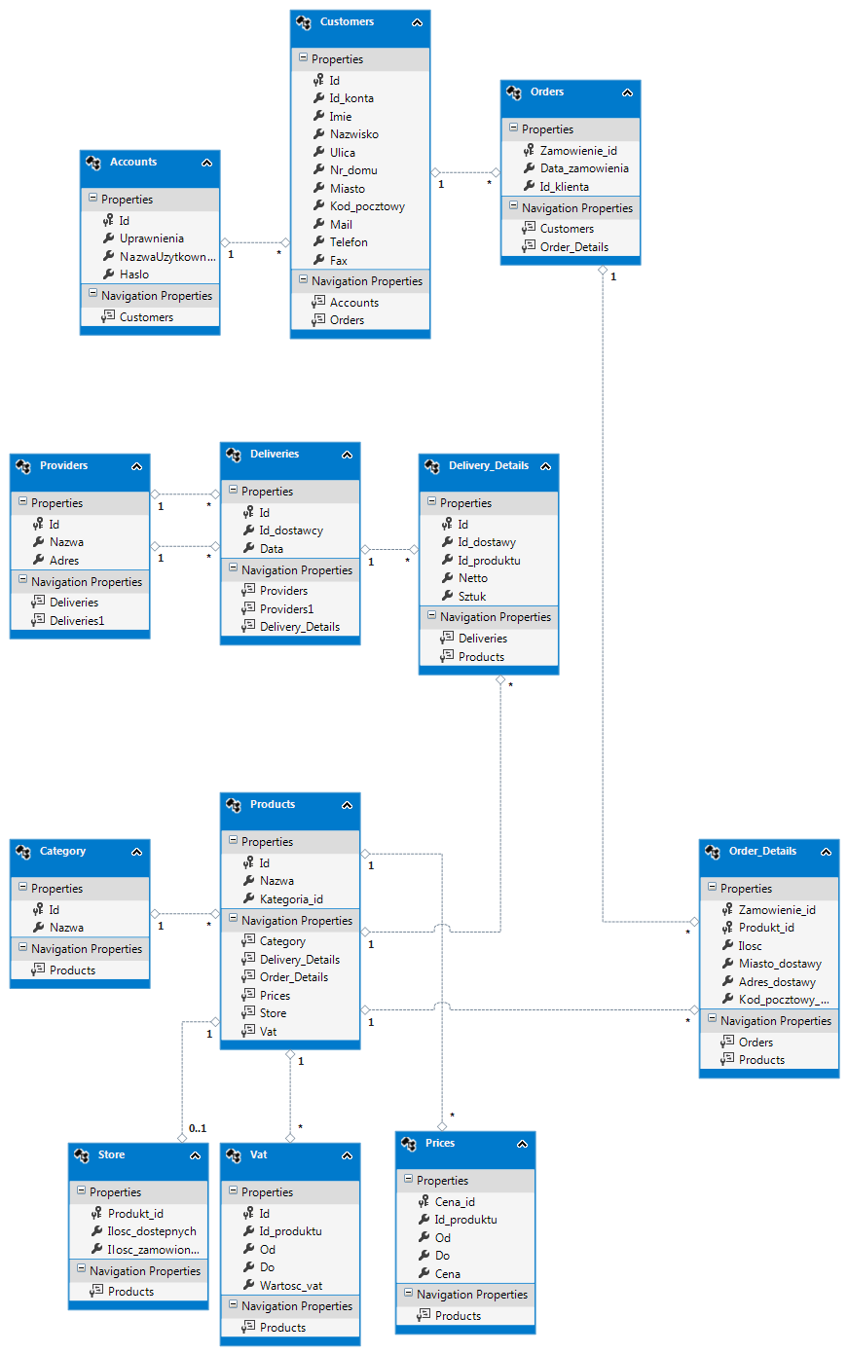
Data Model

Tables

Account – Table which contains information on every user. Passwords are encoded in MD5
Category – Table which contains all categories. They are used to make managing products more effective
Customer – Table which contains detailed information on every customer
Delivery – Table which contains information about every delivery(date etc.)
DeliveryDetail – Table which contains information on product and product quantity in specific delivery
Order – Table which contains information about every order(date etc.)
OrderDetail – Table which contains information on product and product quantity in specific order
Price – Table contains all information about prices of products.
Product – Table which contains all product information.
Provider – Table which contains information about every provider.
Store – Table which contains information about the state of store ( number of products)
Vat – Table which contains information about var of specific product

Account
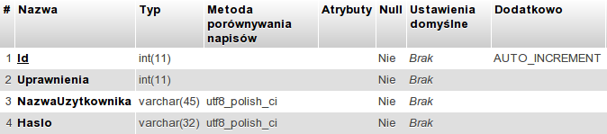

Category

Customer
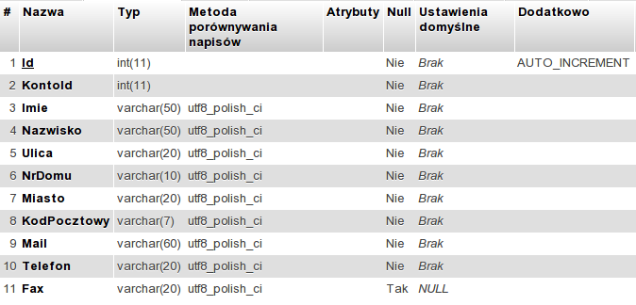

DeliveryDetail
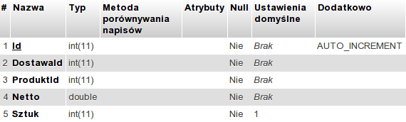

Order
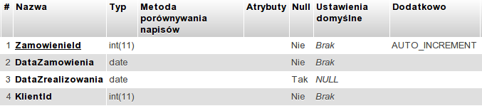

OrderDetail
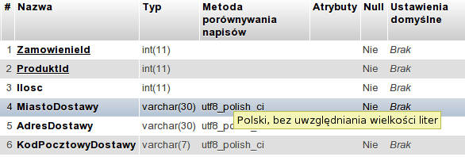

Price
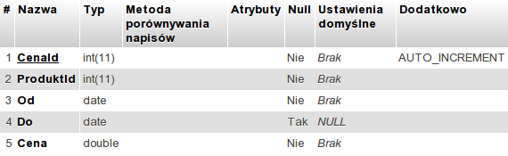

Product
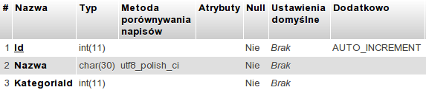

Provider

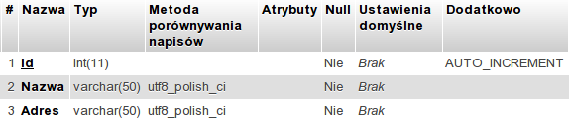

Store
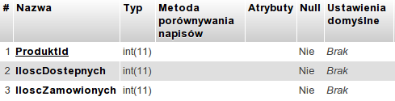

Vat
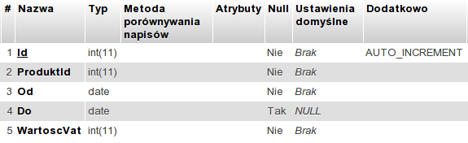

Backup

!MATEUSZ!

Function Design
[This section is where the detailed functional design work starts. The functions of the system are designed with reference to the Use Cases.]

Function1 name

Description

[Describe the system function]

Performance Issues

[Describe any expected performance issues with the function (generally applies only for very high volume transactions or complicated nested database queries. Also indicate strategy for dealing with the issues].

Use Cases Referenced

[List the Use Cases the function deals with]

Trigger

[How is the function initiated?]

Pre-Condition

[Pre conditions for invoking the function]

Process Steps

[With reference to the Use Case(s), detail the steps and operations of the function with emphasis on the system operations, rather than the user. This will generally involve the use of a diagram with conditions, logic and results all referenced]

User Interface Reference

Look and Feel / User Experience
[Additional GUI mock drawings, prototype screenshots, or systems with similar GUI patters screenshots, should be places here.]

Issues and Questions
[Issues and questions register specific to this document. This does not take the place of any project issues registers]

Issue/Question | Status | Priority | Date Resolved | Solution/Answer

